**Introduction: let us understand the satellite imagimg**

File inventory

* data_set1/JL1KF01C_…L1_MSS_598095.tif (multispectral)
* data_set2/JL1KF01C_…L1_PAN_598095.tif (panchromatic)

Each image is shipped with metadata (.xml), a thumbnail JPG, Shapefile layers, and an RPC file that contains the sensor model used for geolocation.

1- the satellite id is: <SatelliteID>JL1KF01C</SatelliteID> ,got it from the XML and it is the same satellite for the 2 images.

2- sensor name for both images: PMSR2

3- the real difference is the bands number

4- the MSS has a multispectrum and the PAN is a uni spectrum which gives more geographic details.

1- MSS

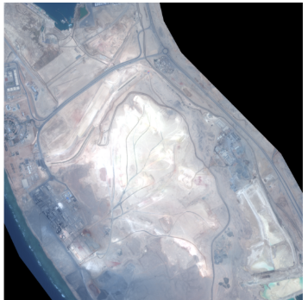

2- PAN

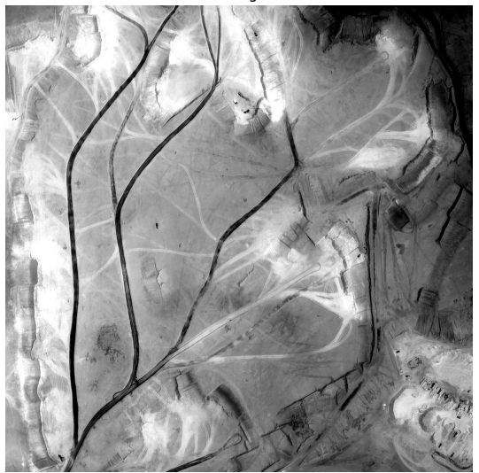

Core image characteristics:

**Multispectral (MSS)**

Dimensions…… 4 086 (px) × 5 422 (px)

Bands………… 4 (Blue, Green, Red, NIR) – 16-bit unsigned

Spatial GSD…. ≈ 2.4 m / px (derived from RPC scale values)

Foot-print…… ~10.3 km × 12.6 km (≈ 130 km²)

Centre point… 27.5375 ° N, 35.5538 ° E

Radiometry….. 11-bit data stored in a 16-bit container; no‐data flag not set.

**Panchromatic (PAN)**

Dimensions…… 16 341 (px) × 21 710 (px)

Bands………… 1 (broad 0.45–0.90 µm) – 16-bit unsigned

Spatial GSD…. ≈ 0.6 m / px

Foot-print…… identical ground area as MSS (same RPC centre & scale)

Centre point… 27.5374 ° N, 35.5537 ° E

Radiometry….. 11-bit data stored in 16-bit container; excellent dynamic range

Quality Snapshot

Both images are cloud-free, well-exposed and without notable sensor artefacts. The PAN image is sharply focused, allowing **individual vehicles, small buildings, tree crowns, and road markings to be resolved**. The MSS image is lower in resolution but provides spectral contrast (especially the NIR band) that is useful for **vegetation/water segmentation and change detection.**

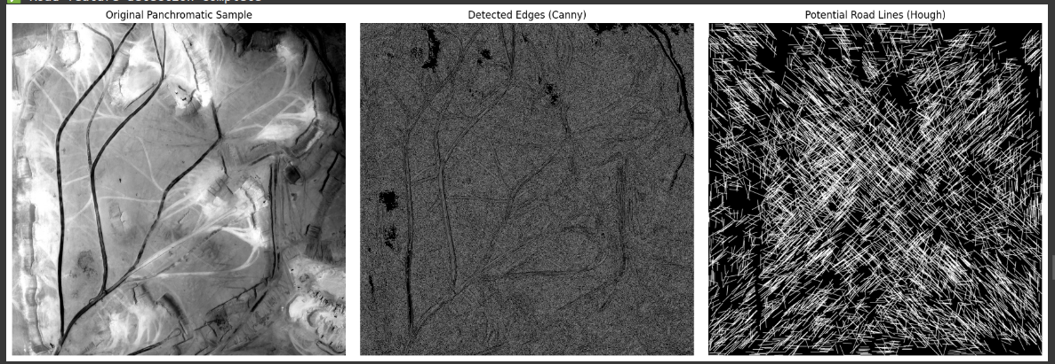

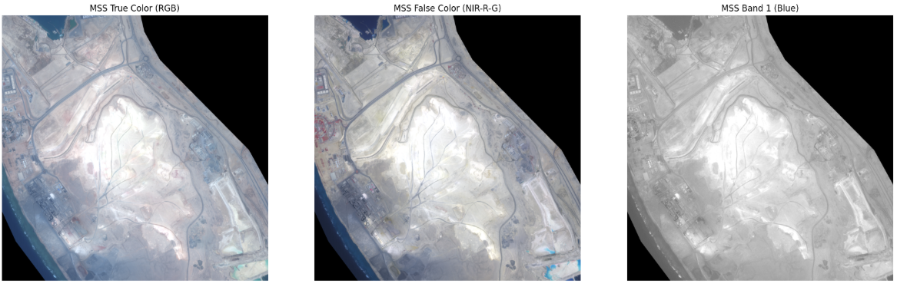

**Object detection for satellite images**

**Reading RPCs for mapping the coordinates to pixel values:**

Given a geographic point (lat, lon, height) you can compute its pixel coordinate, or invert the model (iteratively) to get lat/lon from a pixel.

GIS tools such as GDAL, ERDAS, ENVI, and commercial photogrammetry suites read RPCs directly;

For computer-vision or deep-learning tasks we can convert pixel detections back to coordinates, measure distances, or fuse with other geodata.

**Spectral Indices (NDVI / NDWI) for Land-Cover Masks:**

These are analytical formulas derived from physics of vegetative and water reflectance.

Formulas

NDVI = (NIR − Red) / (NIR + Red)

Healthy vegetation strongly reflects NIR and absorbs red; index ranges −1 … 1 and vegetation ≈ 0.3+.

NDWI = (Green − NIR) / (Green + NIR)

Water absorbs NIR and moderately reflects green; values > 0.1–0.2 are usually water pixels.

The 4-band MSS image already has the key spectral channels; indices are cheap and explainable.

A good baseline for rapid water/vegetation change detection without training data.

You can later replace or augment them with a CNN (e.g. U-Net, DeepLab) trained on labelled land-cover maps for finer classes such as barren, cropland, etc.

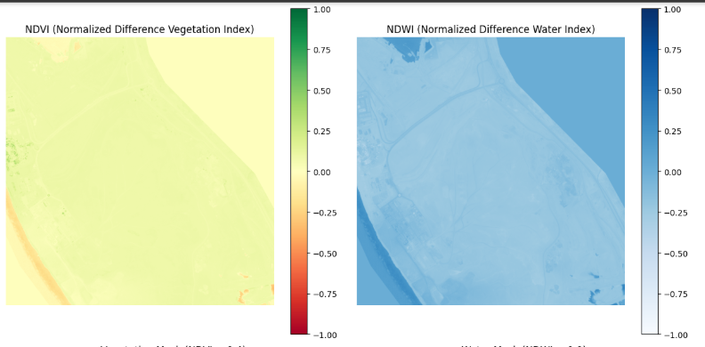

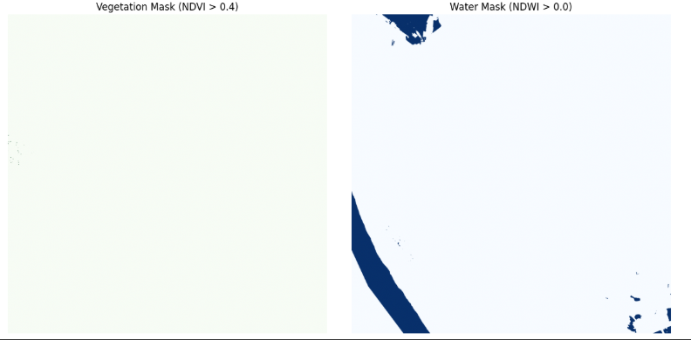

What cannot be done with just B,G,R,NIR

• NDBI (Built-up), NDMI (Moisture), MNDWI , NBR (burn scar), NDSI (snow), etc. all need SWIR or additional bands.

**Land Surface Temperature or emissivity needs thermal IR.**

**SAM masking**

1. SAM is a general segmentation model. To specifically target roads or buildings, you would typically

2. Provide precise input prompts (points/boxes) on the features you want to segment

3. Use SAM's output masks as input to further processing or refinement steps

4. For large areas, you might need to tile the image and run SAM on each tile.")

5. Consider using a specialized model fine-tuned for roads if high accuracy is needed.")

**Conclusion:  
 I bilieve there is a chance to get benefit from the satellite images but it differs depending on:**

**1- resolution**

**2- the objects we need to detect/analyze**

**3- the area per pixel (for example 0.3 m means each pixel covers 0.3 m for the one pixel)**

**I tried to segment the roads and did not get good results from the first time, but I learned a lot from the task.**